***Part A***

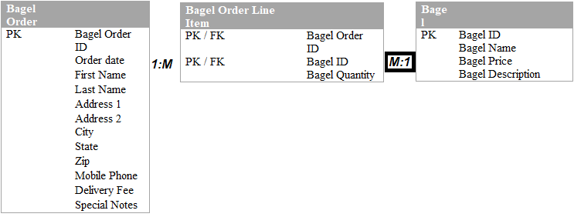

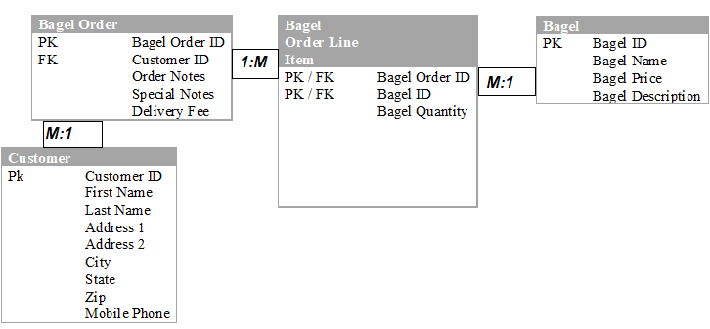

***Part B:***

***SQL:*** CREATE TABLE `Coffee` (

`coffee_id` int(11) NOT NULL,

`shop_id` int(11) NOT NULL,

`supplier_id` int(11) NOT NULL,

`coffee_name` varchar(30) DEFAULT NULL,

`price_per_pound` decimal(5,2) DEFAULT NULL

) ALTER TABLE `Coffee`

ADD PRIMARY KEY (`coffee_id`),

ADD KEY `shop_id` (`shop_id`),

ADD KEY `supplier_id` (`supplier_id`);

ALTER TABLE `Coffee`

MODIFY `coffee_id` int(11) NOT NULL AUTO_INCREMENT;

ALTER TABLE `Coffee`

ADD CONSTRAINT `coffee_ibfk_1` FOREIGN KEY (`shop_id`) REFERENCES `Coffee_Shop` (`shop_id`),

ADD CONSTRAINT `coffee_ibfk_2` FOREIGN KEY (`supplier_id`) REFERENCES `Supplier` (`supplier_id`);

***SQL:*** CREATE TABLE `Coffee_Shop` (

`shop_id` int(11) NOT NULL,

`shop_name` varchar(50) DEFAULT NULL,

`city` varchar(50) DEFAULT NULL,

`STATE` varchar(2) DEFAULT NULL

) ALTER TABLE `Coffee_Shop`

MODIFY `shop_id` int(11) NOT NULL AUTO_INCREMENT;

ALTER TABLE `Coffee_Shop`

ADD PRIMARY KEY (`shop_id`);

ALTER TABLE `Coffee_Shop`

MODIFY `shop_id` int(11) NOT NULL AUTO_INCREMENT;

***SQL:*** CREATE TABLE `Employee` (

`employee_id` int(11) NOT NULL,

`first_name` varchar(30) NOT NULL,

`last_name` varchar(30) NOT NULL,

`hire_date` date NOT NULL,

`job_title` varchar(30) NOT NULL,

`shop_id` int(11) NOT NULL

)

ALTER TABLE `Employee`

ADD PRIMARY KEY (`employee_id`);

ALTER TABLE `Employee`

MODIFY `employee_id` int(11) NOT NULL AUTO_INCREMENT;

***Supplier:***

***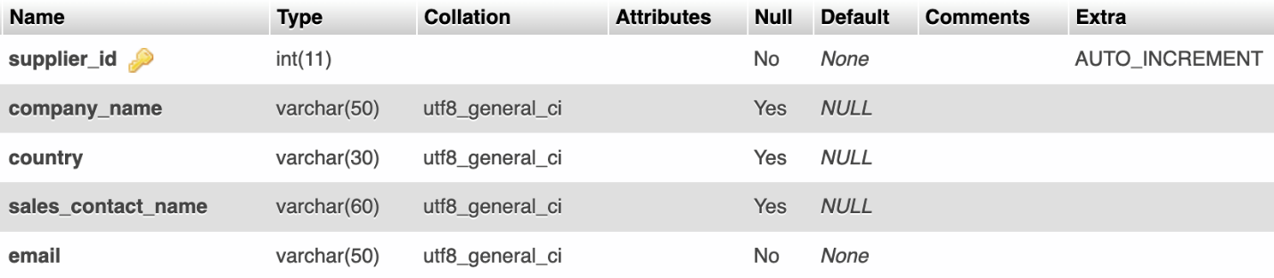  
SQL:*** CREATE TABLE `Supplier` (

`supplier_id` int(11) NOT NULL,

`company_name` varchar(50) DEFAULT NULL,

`country` varchar(30) DEFAULT NULL,

`sales_contact_name` varchar(60) DEFAULT NULL,

`email` varchar(50) NOT NULL

) ALTER TABLE `Supplier`

ADD PRIMARY KEY (`supplier_id`);

ALTER TABLE `Supplier`

MODIFY `supplier_id` int(11) NOT NULL AUTO_INCREMENT;

***View:***

***SQL:***

CREATE VIEW Customer AS

SELECT CONCAT(CustomerFirstName, ' ', CustomerLastName) AS Name, CustomerStreetAddress1,

CustomerStreetAddress2, CustomerCity, CustomerState, CustomerZip, CustomerHomePhone, CustomerMobilePhone, CustomerOtherPhone

FROM Customers_3NF